# **Understanding Urban Mobility Patterns Through Bike Sharing Data**

By Matthew Latondresse

## **Business Problem**

Urban areas face growing challenges in transportation planning due to increasing population density and the need for sustainable mobility solutions. This project aims to leverage bike-sharing data to analyze urban mobility patterns, thereby assisting in the improvement of city transportation planning and infrastructure development. Through the analysis of usage patterns, cities can optimize bike lane locations, enhance safety measures, and better meet the transportation needs of their residents.

## **Background/History**

Bike-sharing systems have gained popularity worldwide as a sustainable mode of transportation that complements existing public transit. These systems allow users to rent bikes from a network of docking stations spread throughout a city, promoting increased mobility and accessibility while reducing reliance on motor vehicles. The proliferation of bike-sharing programs has generated a wealth of data on urban mobility patterns, providing a unique opportunity for cities to understand and improve their transportation infrastructure. Peter Midgley’s study highlighted the following in 2009, Smart bike-sharing systems provide the missing link between existing points of public transportation and desired destinations, offering a new form of mobility that complements the existing public transport systems. With systems operating in 78 cities across 16 countries, using around 70,000 bikes, these innovative systems represent a pivotal shift towards sustainable urban transportation, seamlessly integrating technology with mobility to enhance the urban living experience.

## **Data Explanation**

### **Data Preparation**

The analysis utilizes public bike-sharing datasets, which include information on trip durations, start and end times, station locations, and anonymized user data. These datasets are preprocessed to handle missing values, remove outliers, and ensure data quality and consistency.

### **Data Dictionary**

* **Trip Duration**: The total time a bike is rented.
* **Start Time**: The time a bike rental begins.
* **End Time**: The time a bike rental ends.
* **Start Station Location**: Geographic coordinates of the rental's starting point.
* **End Station Location**: Geographic coordinates of the rental's end point.
* **User Type**: Categorization of users (e.g., casual, member).

## **Methods**

The project employs a range of data analysis including descriptive statistics for usage pattern summarization, time series analysis for trend identification, geospatial analysis for demand mapping, and clustering techniques for user segmentation.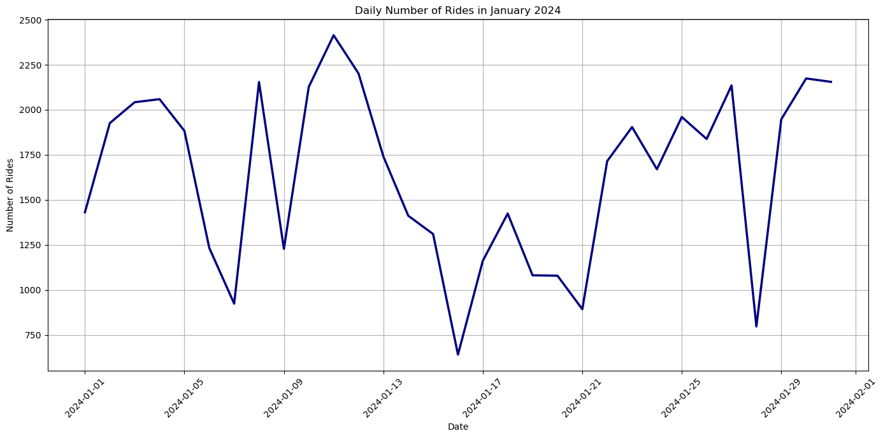

The above graph is utilizing data from citibikenyc. In just capturing the month of January alone we are already making some interesting findings. Even during the winter months, motor vehicle alternatives are being used to a high degree.

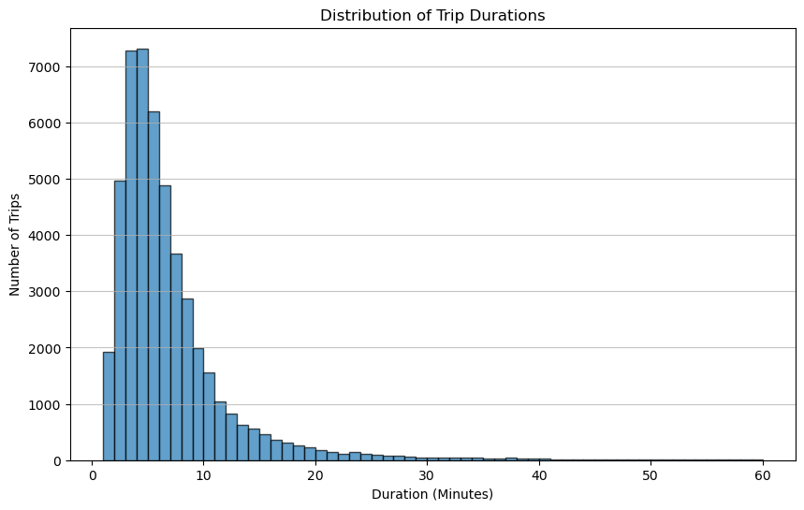

Though due to the colder weather we can see that the total trip durations are kept short.

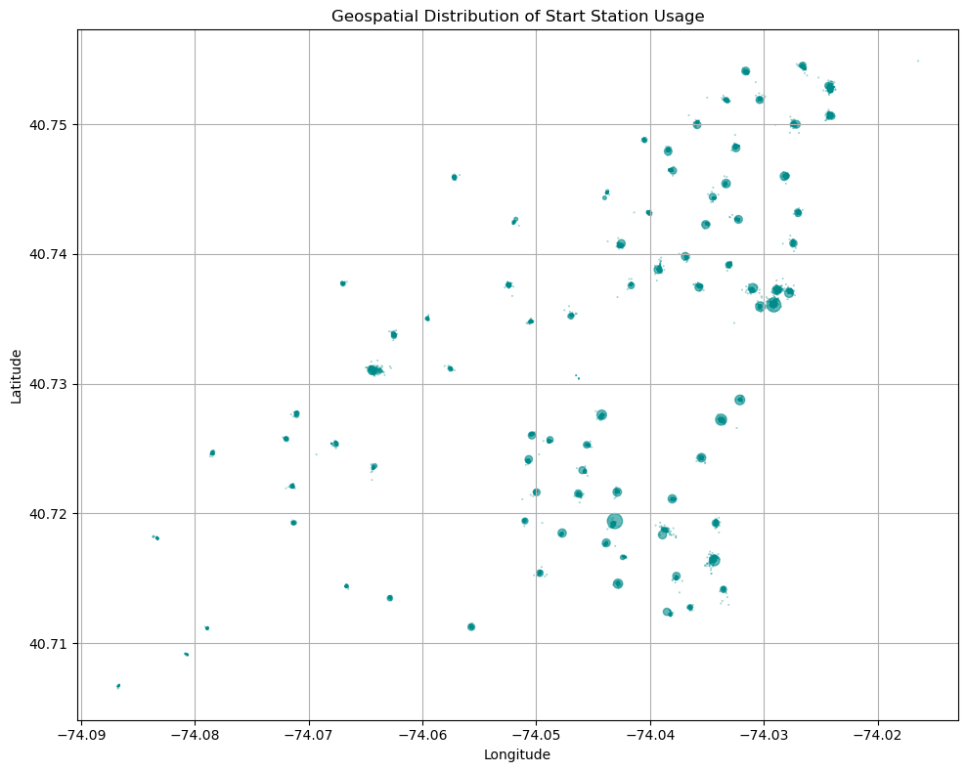

The above graph seeks to find if there are key spots that users seek to rent bikes from. There are some interesting insights that can be gained from this, and further investigations may reveal why certain locations are more popular than others.

## **Analysis**

The analysis reveals significant insights into urban mobility, such as peak usage times, popular routes, and seasonal variations in bike usage. These insights are critical for informing transportation planning and infrastructure investment decisions.

## **Conclusion**

This study demonstrates the value of bike-sharing data in understanding and enhancing urban mobility. By analyzing this data, cities can make informed decisions to improve transportation infrastructure, promote sustainable mobility, and meet the evolving needs of their residents.

## **Assumptions**

* The data accurately represents the broader user base of the bike-sharing program.
* Seasonal and weather-related factors have a consistent impact on bike-sharing usage.

## **Limitations**

* The analysis may not account for all factors influencing bike-sharing usage, such as unrecorded short trips or maintenance issues.
* Changes in urban infrastructure or transportation policies could affect the applicability of the findings over time.

## **Challenges**

* Ensuring data quality and handling large datasets pose significant technical challenges.
* Dynamic urban environments require continuous data analysis to maintain the relevance of findings.

## **Future Uses/Additional Applications**

Beyond transportation planning, bike-sharing data could be used to inform public health studies, environmental impact assessments, and economic development strategies.

## **Recommendations**

* Expand and optimize the bike-sharing network based on demand hotspots.
* Implement targeted safety and infrastructure improvements in high-usage areas.
* Engage with the community to ensure the bike-sharing system meets diverse transportation needs.

## **Implementation Plan**

* Collaborate with city planners and transportation departments to integrate findings into urban development projects.
* Deploy data analytics tools for ongoing monitoring and analysis of bike-sharing usage patterns.
* Establish feedback mechanisms with users to continually refine and improve the bike-sharing program.

## **Ethical Assessment**

The project adheres to ethical guidelines by ensuring user data privacy, addressing potential biases, and safeguarding against unauthorized data access. It seeks to promote equitable and sustainable urban mobility without reinforcing existing inequalities.

### **10 Questions an Audience Might Ask**

* How does weather affect bike-sharing usage patterns?
  + To analyze how weather affects bike-sharing usage patterns, we could correlate trip data with weather conditions on specific dates and times. For instance, we might find fewer trips on days with adverse weather conditions (rain, snow, extreme temperatures) and more on days with favorable conditions. However, this dataset alone does not contain weather information, so external weather data for the same dates and locations would be needed for a comprehensive analysis.
* Can the data predict the impact of urban events on mobility?
  + Yes, by examining the frequency and patterns of bike trips before, during, and after urban events (e.g., concerts, sports events, festivals), one can infer their impact on mobility. An increase in trips starting or ending at locations near event venues could indicate a significant impact. However, precise predictions would require additional data on event schedules and locations.
* How does the analysis account for new bike-sharing stations?
  + Analysis can account for new stations by tracking the introduction of station IDs over time. Increases in trips from newly established stations can indicate how quickly and effectively they are integrated into the existing network. Changes in usage patterns could also reflect the impact of new stations on surrounding areas.
* What are the privacy implications of using bike-sharing data?
  + Using bike-sharing data raises privacy concerns related to tracking individuals’ movements. While the dataset does not contain directly identifiable personal information, patterns in trip data (especially when combined with other data) could potentially identify individuals. It's essential to anonymize data, limit access, and ensure compliance with privacy laws and guidelines.
* How can cities ensure equitable access to bike-sharing programs?
  + Cities can promote equitable access by strategically placing bike-sharing stations in underserved areas, offering affordable membership options for low-income residents, and providing alternatives for people without smartphones or credit cards. Accessibility for people with disabilities and multilingual support are also important factors.
* What are the environmental benefits of promoting bike-sharing?
  + Promoting bike-sharing can reduce carbon emissions, decrease traffic congestion, and lower the dependence on fossil fuels by providing an eco-friendly alternative to cars. It also contributes to improved air quality and promotes a healthier lifestyle among city residents.
* How can the findings support the development of green infrastructure?
  + Findings can guide the development of bike lanes, greenways, and other infrastructure that supports cycling, by identifying high-demand areas and routes frequently used by bikers. This can lead to safer and more convenient cycling conditions, further encouraging bike-sharing usage.
* What challenges do cities face in scaling up bike-sharing programs?
  + Challenges include the financial sustainability of the programs, ensuring the safety and maintenance of the bike fleet, integrating bike-sharing with existing public transport, and addressing the needs of all city residents. Vandalism and theft may also pose significant challenges.
* How do user types differ in their mobility patterns?
  + Analysis could reveal differences in usage patterns between members and casual users, such as differences in trip durations, frequency, and preferred routes or times of day. Members might use the service more for daily commutes, while casual users might use it more sporadically or for leisure activities.
* What are the long-term implications of these findings for urban planning?
  + Long-term implications could include shifts towards more sustainable and flexible urban mobility solutions, with increased investments in cycling infrastructure and integrated transportation systems. Data-driven insights could also guide policies to reduce urban congestion and emissions, promoting healthier and more livable cities.

Resources

Midgely, P. (2009). *The Role of Smart Bike-sharing Systems in Urban Mobility VL*. Research Gate. <https://www.researchgate.net/publication/242235724_The_Role_of_Smart_Bike-sharing_Systems_in_Urban_Mobility>

Citi Bike System Data: Citi Bike NYC <https://citibikenyc.com/system-data>